**Quick Overview present in read me**

Homepage:

When user first enters site, here by localhost:3000.

We use react router to display the Transact page.



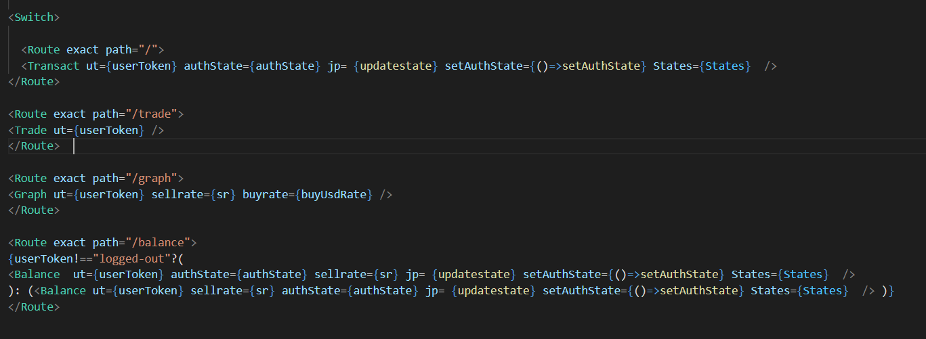

We show a dynamic calculator that changes values here, notice how LL and $ are exchanged when user changes dropdown value, before pressing the button. Achieved using states

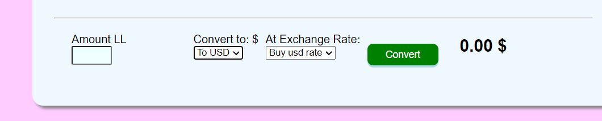

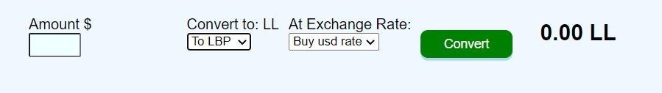

When adding a transaction:

When adding a transaction, we check for the user token to see if we should add the transaction under a certain user or not.

If we enter 8000lbp and 1 usd and press enter, the transaction is immediately added to the user transactions page.

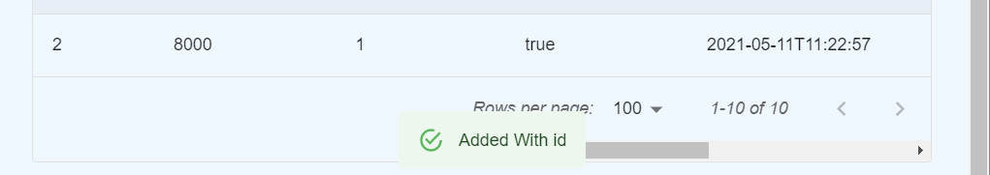

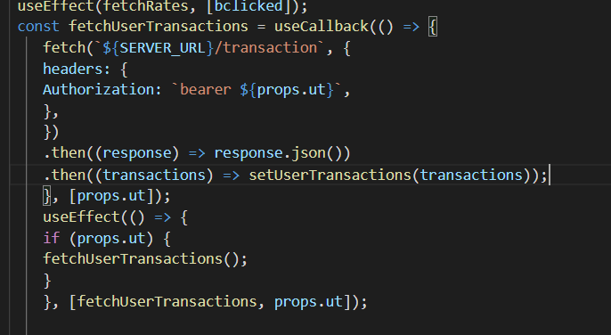

Of course, the user can’t have negative or zero as inputs.

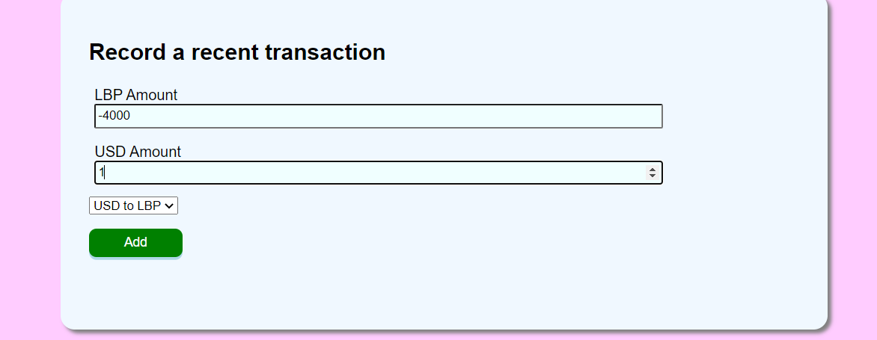

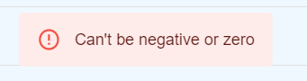

Graph:

Here we have the graph and insights which change upon the days the user wants to go back for.

dbused are the days the user wants to go back in. Whenever this value is changed, we call on the functions that update the graph (checkdays) and insights.

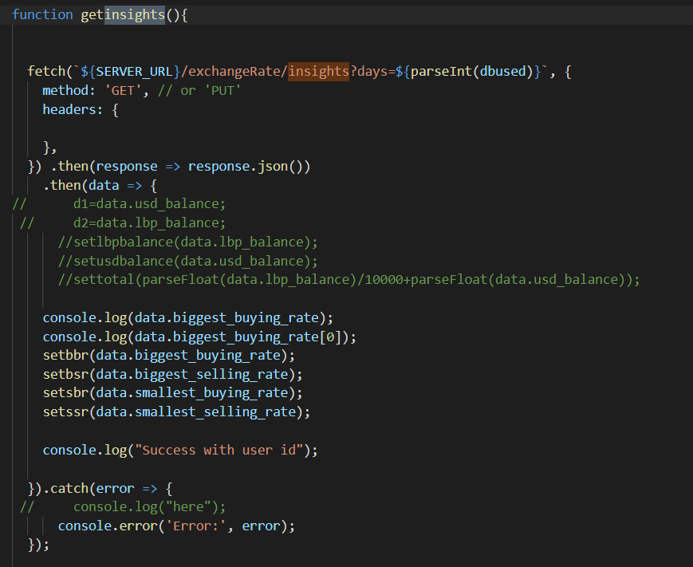

Trade:

In the trade page we add the trade request section only if a user token exists.

However, we do show the available trades either way, available trades work similarly to user transactions and trade request similar to add a transaction.

We show an alert when trade is added successfully.

When a logged in user presses confirm on a trade, if he has enough funds, he will be able to complete the trade, however, if he doesn’t he is presented with an alert saying not enough xx funds where xx are the funds he does not have enough of. He also can not confirm his own trades.

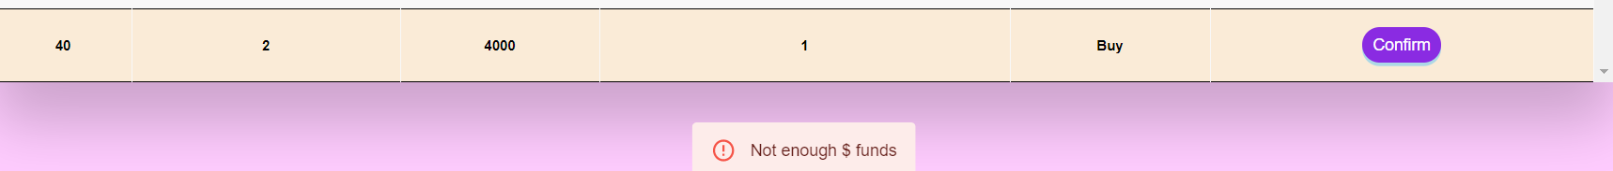

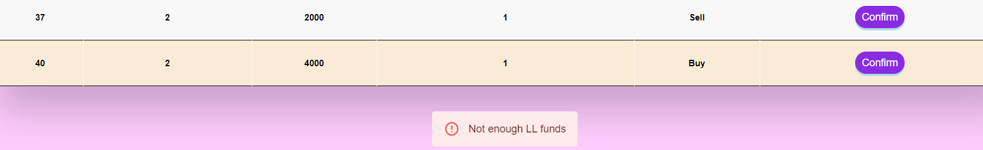

However, on a successful trade, the user’s balance is updated.

Here’s the balance page:

The user can check his lbp and usd balance, and total balance in usd which uses the current sell rate.

He can also check his pending trades and cancel them and his balance immediately gets updated.

This is done by making a listener that changes value upon cancelling calling update balance whenever the listener changes.

The user can also deposit and withdraw, of course we cant have negative or unexpected numbers here.

And the user cant withdraw an amount he does not have.

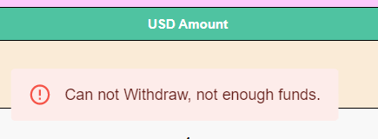

When logged out, the user has to login to access this page.